End-of Chapter 1 Questions

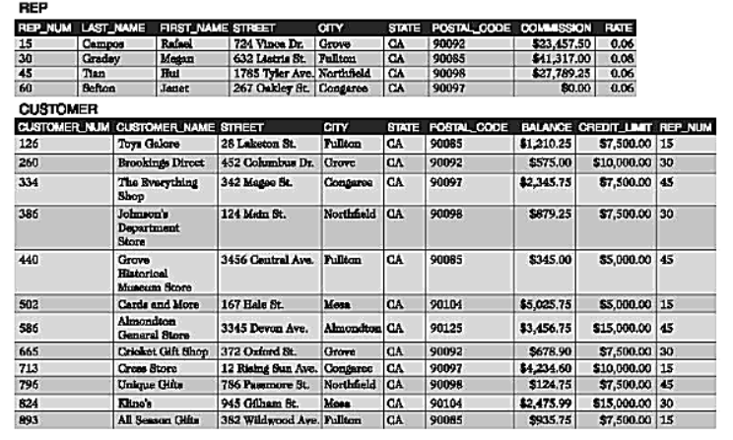

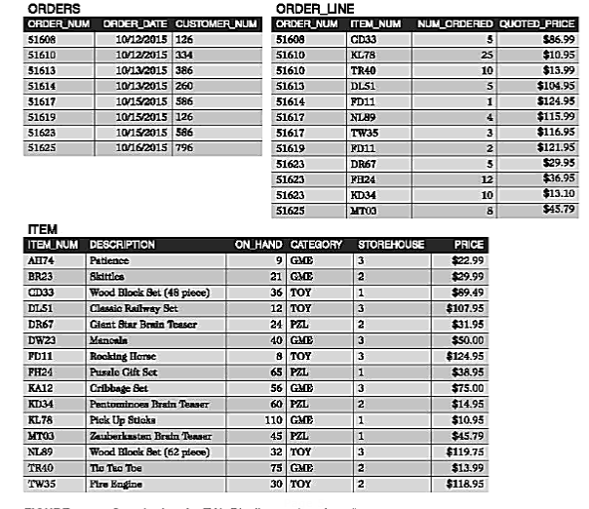

1. The following customers all have a credit limit of 7,500 or less: Toys Galore, The Everything Shop, Johnson’s Department Store, Grove Historical Museum Store, Cards and More, Cricket Gift Shop, Unique Gifts and All Seasons Gifts.
2. Two orders were placed on 10/15/2015 by customer number 586: order numbers 51617 and 51623
3. Units on hand X price = ON HAND VALUE. TOY CATEGORY

|  |  |  |  |  |
| --- | --- | --- | --- | --- |
| **CATEGORY: TOY** | | | | |
| **ITEM_NUM** | **DESCRIPTION** | **UNITS** | **PRICE** | **ON_HAND VALUE** |
| CD33 | Wood Block Set (48 piece) | 36 | $89.49 | $3221.64 |
| DL51 | Classic Railway Set | 12 | $107.95 | $1295.40 |
| FD11 | Rocking Horse | 8 | $124.95 | $999.60 |
| NL89 | Wood Block Set (62 piece) | 32 | $119.75 | $3832.00 |
| TW35 | Fire Engine | 2 | $118.95 | $237.90 |

|  |  |
| --- | --- |
| **Category: PLZ** | |
| **ITEM_NUM** | **DESCRIPTION** |
| DR67 | Giant Star Brain Teaser |
| FH24 | Puzzle Gift Set |
| KD34 | Pantominoea Brain  Teaser |
| MT03 | Zauberkastan Brain Teaser |

1. Customers with a balance that exceeds their credit limit: One customer: Cards and More,

|  |  |  |
| --- | --- | --- |
| **ITEM_NUM** | **DESCRIPTION** | **PRICE** |
| KL78 | Pick Up Sticks | $10.95 |

1. Least expensive item in the database.

|  |  |  |  |
| --- | --- | --- | --- |
| **Category: ORDERS** | | | |
| **ORDER_NUM** | **ORDER_DATE** | **CUSTOMER_NUM** | **CUSTOMER_NAME** |
| 51608 | 10/12/2015 | 126 | Toys Galore |
| 51610 | 10/12/2015 | 334 | The Everything Shop |
| 51613 | 10/13/2015 | 386 | Johnson’s Department Store |
| 51614 | 10/13/2015 | 260 |  |
| 51617 | 10/15/2015 | 586 |  |
| 51619 | 10/15/2015 | 126 |  |
| 51623 | 10/15/2015 | 586 |  |
| 51625 | 10/16/2015 | 796 |  |

1. 